# DATA ANALYTICS

ASSIGNMENT-4

TASK-1

FIXED LOD : This function allows users to define a fixed level of detail for a particular calculation, regardless of the level of detail in their view. Fixed LOD functions are useful when users need to perform calculations at a specific level of detail, such as at the customer or product level.

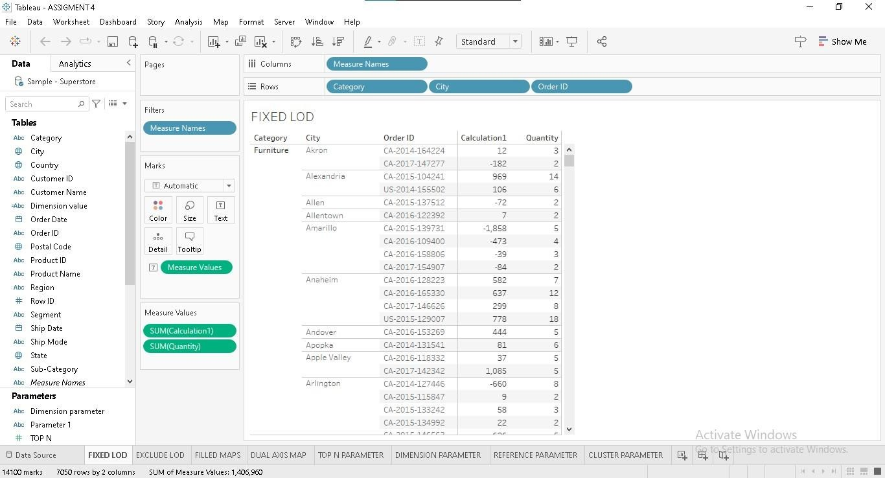

In below visualizations we can see that different data like measure names values are considered as the columns and similarly the different data like category, city and order id values are considered as the rows based on this values we can observe that a fixed column (Calculation 1) with measured values are obtained.

EXCLUDE LOD : These functions allow users to exclude specific fields from the calculation while still preserving the level of detail of the view. Exclude LOD functions are useful when users need to perform calculations that exclude specific fields but still need to perserve the level of detail in their view.

In below visualizations we can observe that excluded values to get the detailed view of sales compared to fixed lod we excluded the segemts field from the rows.

We use category and product Id and city in rows and measured names in column.

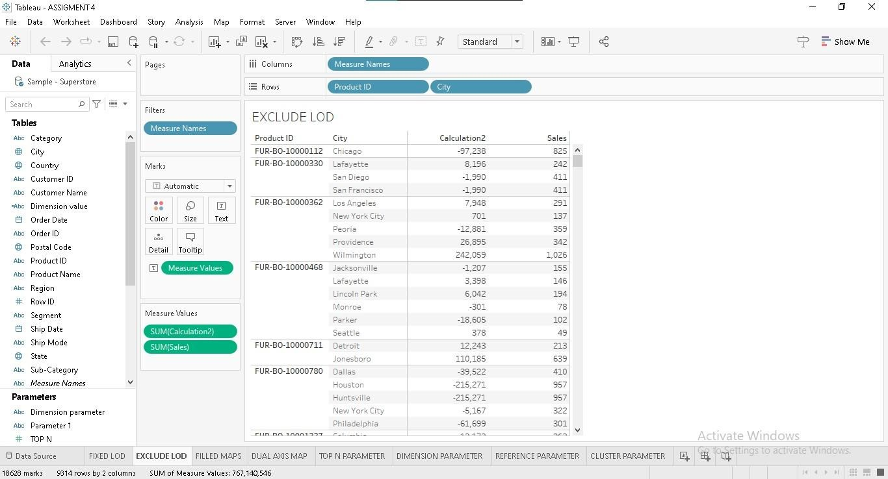

Task-2

Visualizing geographic information helps data consumers quickly and easily derive insights and meaning. Tableau is designed to make the most of geographical data, with instant geocoding, tableau automatically turns the location data. Map visualization is used to analyze and display the geographically related data and present in the forms of map.

In Task 2 we created different map visualizations using geographical data

They are :

1.Filled map

2. Dual Axis map

In this visualizations global super store data is used,

Filled Map : Filled map visualization is a method of graphically representing numerical data where the value of each data point is indicated using colors.

In this Filled map longitude value is taken in column field and latitude value is taken in row field then we get resultant Filled map. Here we can observe that the sales values are represented with different shades of colours respected to different areas.

Filled map

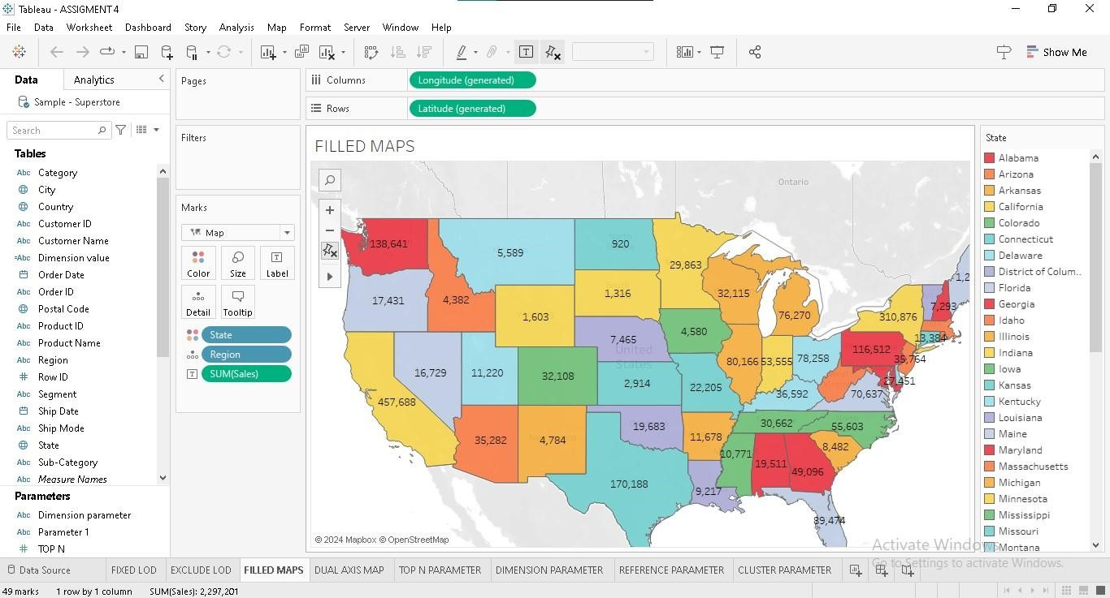

Dual Axis : Dual axis map is a map with two sets of geographical data overlaid on top of one another.

To create dual axis map we use longitude in column and latitude in row as well as multiple fields in colors, state field and country in detail then we get the resultant dual axis map.

With this dual axis layered map, users can easily tell which state generated more Profit and Quantity while at the same time tell the leading cities within those high performing states.

Dual Axis map

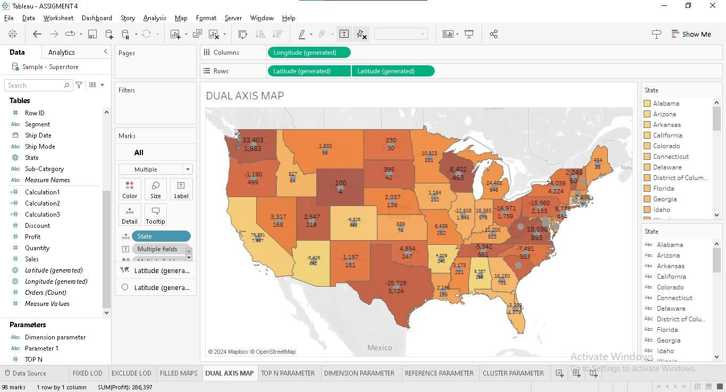

Task-3

Top N Parameter : A Top N parameter returns data according to a number you assign it, hence the N in the name.

In below visualization we can observe that the Top N parameter display the top 100 sub category values according to their sales. We used sum of sales in column field and sub category in rows field that we got the resultant visualization showing top 10 sub category values in a decending order.

## Top N parameter

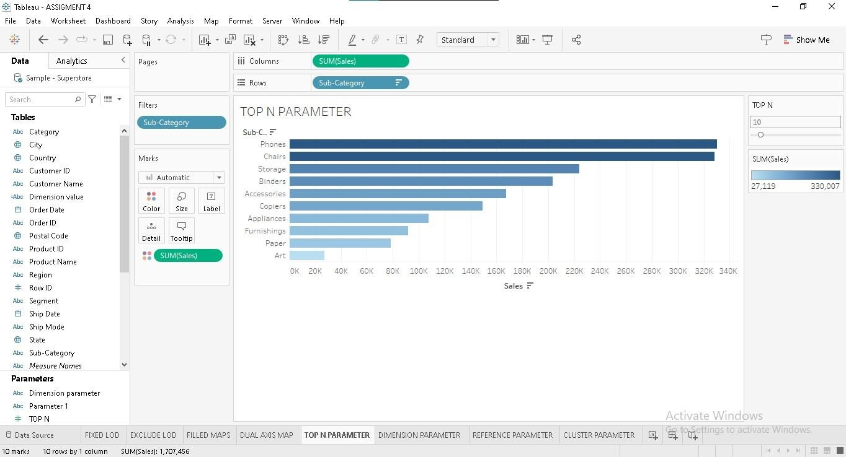

Dimensional Parameter : Dimensions contains qualitative values (such a names, dates or geographical data).

We can use dimensions to categorize, segment, and reveal the details in your data. Dimensions affect the level of detail in the view.

* Dimensions are categorical data fields that represent qualitative attributes.
* They provide context and structure to data, allowing users to segment, group, and categorize information for analysis.
* They are typically used on the rows and columns of a visualization, defining the axes of charts and graphs.

In below visualization we use sum of sales in column field and Dimension value (Calculation) in row field gives the resultant visualization shows the the sales of categorical values by performed calculation.

## Dimension parameter

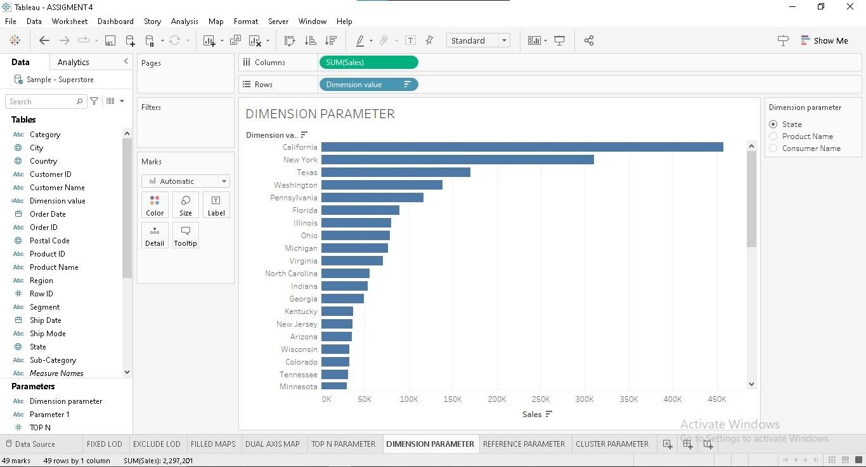

Cluster Parameter : Cluster parameter uses K-Means as the clustering algorithm and groups data based on the mean values of the cluster. Cluster Parameters allows you to group and find underlying trends in your data. However, the built-in cluster does so based on the dimensions in the view.

In below visualization we use sum of sales in column field and Quantity in row field gives the resultant visualization shows the the sales of categorical values by performed cluster parameter underlying sub-category trends in data.

## Cluster parameter

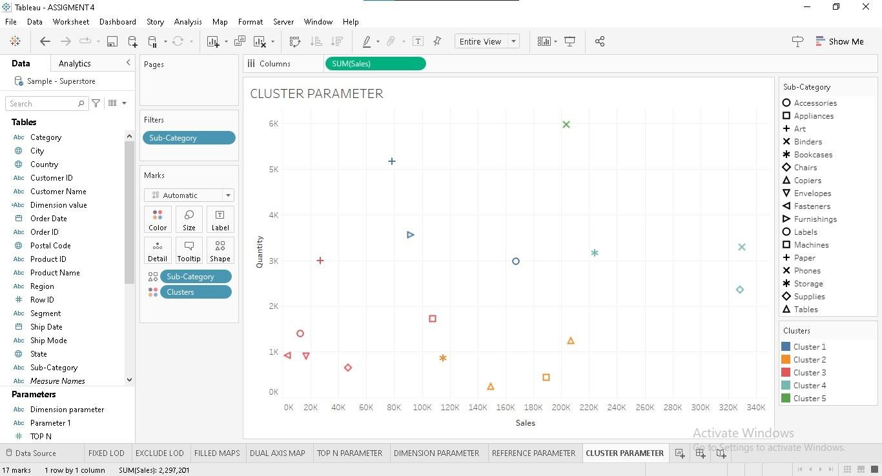

# THANK YOU